# **Task_2: Explain what you analyzed in the below code of testing.**

## ****1)Testing of House Price Prediction model based on a lot size****

Firstly, we are collecting data from the Housing.csv file, then we process data by splitting it into training and testing sets, then we train the model (linear regression) and fit it, and finally, we plot a scatter plot with test data and plot the predicted outputs.

Now we use assert to test the predicted outputs, if the predicted value is less than or equal to 50000, we consider that the test case is passed.

Testing:

Now, we test by putting boundary constraints, if the lot size is between 1650 and 4425 and the house price should be 25000 and 69000, then test case 1 is considered to be passed, or if the lot size is between 4426 and 10500 the house price should be 69001 and 163000, then test case 2 is considered to be passed.

## 2)Testing of Image Classification Model using Assert

Below is an example of an image classification model, once the model is trained and output is generated, we test the model.

1. Load Libraries

1. Load Data based on the labels

1. Process Data



1. Data Augmentation

1. Building the Model

1. Training the model

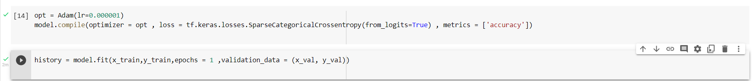

1. Result

1. Testing

For testing the model, we compare the predicted values with the true values and if it’s equal, we consider the test case to pass, else we print the predicted value and true value considering that the test has failed.

Throughout the above tests, we have used the keyword “assert” which allows us to check if a given condition is true and raises an Assertion Error if the condition is false.